**DCIT 208 ASSIGNMENT 1**

**10841867**

**APPIAH DAVID AMOAKO**

***Question 1***

Distinguishing the two requirements is necessary be failure to do will be problematic. Where users are don’t care about how the system works as long as it works, system requirements are very much concerned with how the system works. Failure to distinguish them can cause critical information about the operation of a system to leak.

***Question 2***

Having the members of a software team and respective customers separated geographically can be inevitable sometimes and should not be avoided rather solutions should be generated to combat this problem. Some ways to overcome this problem are designing a using cross-team communication mechanisms. These include video conferences, phone calls or phone conferences that should occur between the software team as well as electronic meetings so team members stay updated on the progress.

***Question 3***

We can avoid the problem by;

1. Comparing and making sure the requirements of the user conform with several other users.

Advantages: - it aids in checking the user’s requirements without outside influence.

Disadvantages: - it slows down the development process

* it increases cost of project if there are project delays

1. by replacing the user with someone else thus if the user’s suggestions bring about problems.

Advantages: - we can determine the perspective views of multiple different users.

* it aids in checking the user’s requirements without outside influence.

Disadvantages: - possible delay of project since new user might not be used to the system

* this results in increase of time of the project in turn increasing cost.

1. By acquiring suggestions from multiple different users.

Advantages: - we can determine the views of different users for a particular problem.

* this also decreases having a typical user.

Disadvantages: - correlation can be resulted on the suggestions and if this increases, cost of the project increases as well.

***Question 4***

a.

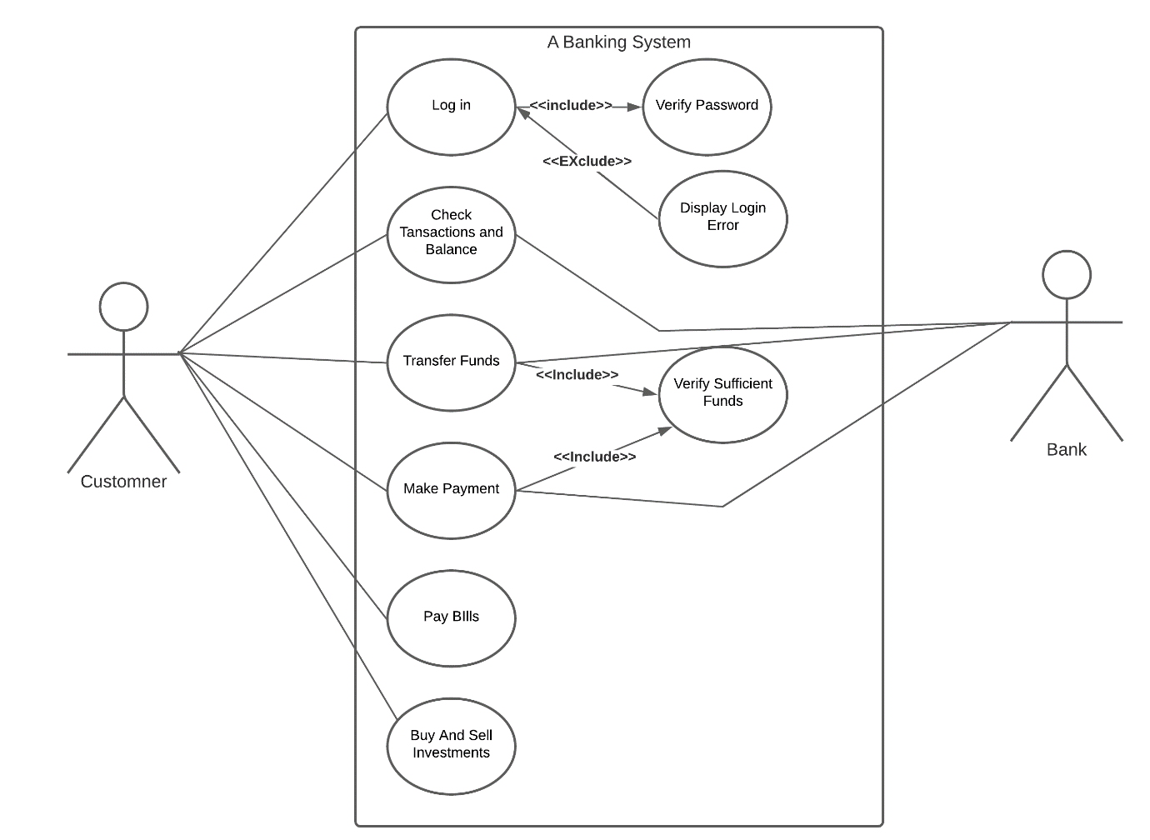

b.

|  |  |
| --- | --- |
| Use case name | Payment of Bill |
| Actors | Customer, account holder |
| Description | Enables user to participate in online bill payment |
| Pre-condition | 1. Connection to the internet  2. Account Number  3. Enough account balance  4. PIN |
| Post-condition | 1. The merchant receives the payment  2. Amount paid is subtracted from the account |
| Basic Path | 1. Choose bill payment  2. Input billing number  3. Chose payment mode (mobile money or net banking)  4. Input PIN |
| Alternate path | 1. Wrong PIN  2. Insufficient account balance  3. System undergoing maintenance  4. Error from server |